**Elastic Bean**

Load Balancer 🡪 2 web servers 🡪 with RDS DB Instance

Created IAM user

Generated Key pairs

Created Security Group for Load Balancer and web Tier

LB- Allow HTTP Port 80 Inbound and outbound

Web Tier – Accept Port 80 from LB & Connect MYSQL:3306 to Database

Create EC2 Load Balancer Assign security Groups

Create EC3 Instance using Amazon Linux AMI

Connect to EC2 Instance via HTTP

Connect EC2 Instance via SSH

Setup DB Tier using RDS

To Complete: Create AMI image of web Tier

Create SDK Development environment

**Restful**

It revolves around resource where every component is a resource and a resource is accessed by a common interface using HTTP standard methods

Here each resource is identified by URIs/ global IDs. REST uses various representations to represent a resource like text, JSON and XML. GET, POST(Write), DELETE, PUT (Update)

**REST** is web standards based architecture and uses HTTP Protocol for data communication

A **web service** is a collection of open protocols and standards used for exchanging data between applications or systems.

JAX-RS Has Annotations

@Path- Relative path of the resource class/method

@GET-HTTP Get request, used to fetch resource.

@PUT-HTTP PUT request, used to create resource.

@POST-HTTP POST request, used to create/update resource.

@DELETE-HTTP DELETE request, used to delete resource.

**SOAP** is an acronym for Simple Object Access Protocol. It is an XML-based messaging protocol for exchanging information among computers. SOAP is an application of the XML specification.

A SOAP message is an ordinary XML document containing the following elements

* Envelope − Defines the start and the end of the message. It is a mandatory element.
* Header − Contains any optional attributes of the message used in processing the message, either at an intermediary point or at the ultimate end-point. It is an optional element.
* Body − Contains the XML data comprising the message being sent. It is a mandatory element.
* Fault − An optional Fault element that provides information about errors that occur while processing the message.

All these elements are declared in the default namespace for the SOAP envelope −

Docker containers wrap a piece of software in a complete filesystem that contains everything needed to run: code, runtime, system tools, system libraries – anything that can be installed on a server. This guarantees that the software will always run the same, regardless of its environment.

Docker is basically a concept of creating a light weight ‘Virtual Machines’ within a Linux Machine by just creating a single process in it.

A container is an enclosed process which is isolated from other process running on a Linux machine. In this way we have full control on what the enclosed process can do and can not do. We can run multiple containers in this fashion. This can be achieved by using [cgroups functionality](https://en.wikipedia.org/wiki/Cgroups" \t "_blank) which is built-in to a Linux kernel long time back. In other words, cgroups provide security to a running process. The concept of containers is old and it proved how good it is in securing the system.

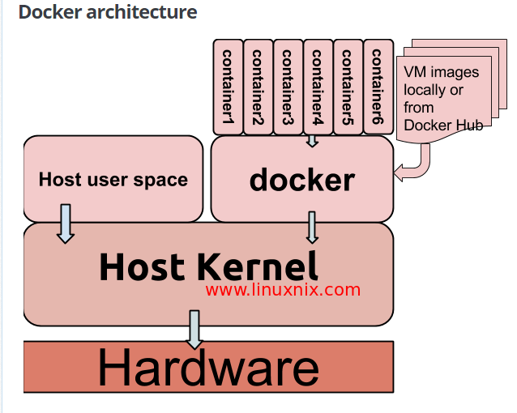

[SAML](https://en.wikipedia.org/wiki/Security_Assertion_Markup_Language) is an identity SSO and federation standard used for authentication. SAML is used as a common identity token format between different applications. SAML and XACML are both defined by [OASIS](https://en.wikipedia.org/wiki/OASIS_(organization)). SAML and XACML were designed to interoperate where SAML is used to carry identity information / virtual identities and XACML is used to drive the access control logic through policies.

**DLDS(Data Labeling and Data Segmentation)**- Allows user to Mask(Encrypt), Anonymize(Substitute) or Redact(Remove) Specific pieces of information within documents or file.

User🡪PEP(Policy Enforcement Point) or Identify Provider

1. Access Approval
2. Feature available
3. Document Redaction

SAML- (Security Assertion Markup Language) Internet SSO

User, Identify Provider (PEP), Service Provider

User has an account at the IDP

User want to use an application on SP

Token created by User send to SalesForce (user, groups, etc) sent to Sales Force

1. User interacts with PEP that uses Activate directory send a token to the site